
2024-2025 6th Grade Supply List
Mr. Scauzillo And
Ms. Minaya

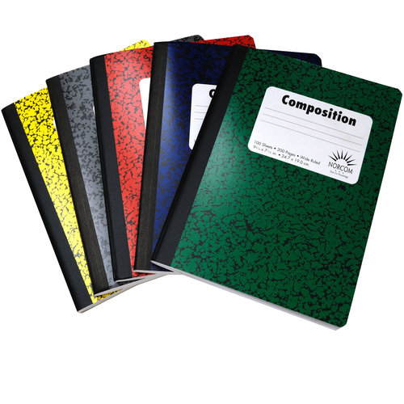
8- Marble White/Black notebooks (Please NO Spiral Notebooks)
4 Packs of loose-leaf paper
1 Pack of WHITE computer paper
2 Packs of graphing paper
6- PLASTIC Folders
1-PLANNER (2024-2025)
10- Boxes of #2 Pencils (Enough to last the year)
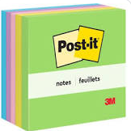
4-Packs of POST-its
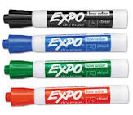
1 pack of HIGHLIGHER
1- Pack of Construction Paper
1- Pack Dry Erase Markers (thick)
6- Glue Sticks
1-Box of Supply/Pencil pouch
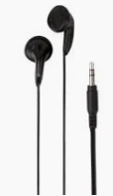
1-Personal sharpener with cover
4-Boxes of Crayons
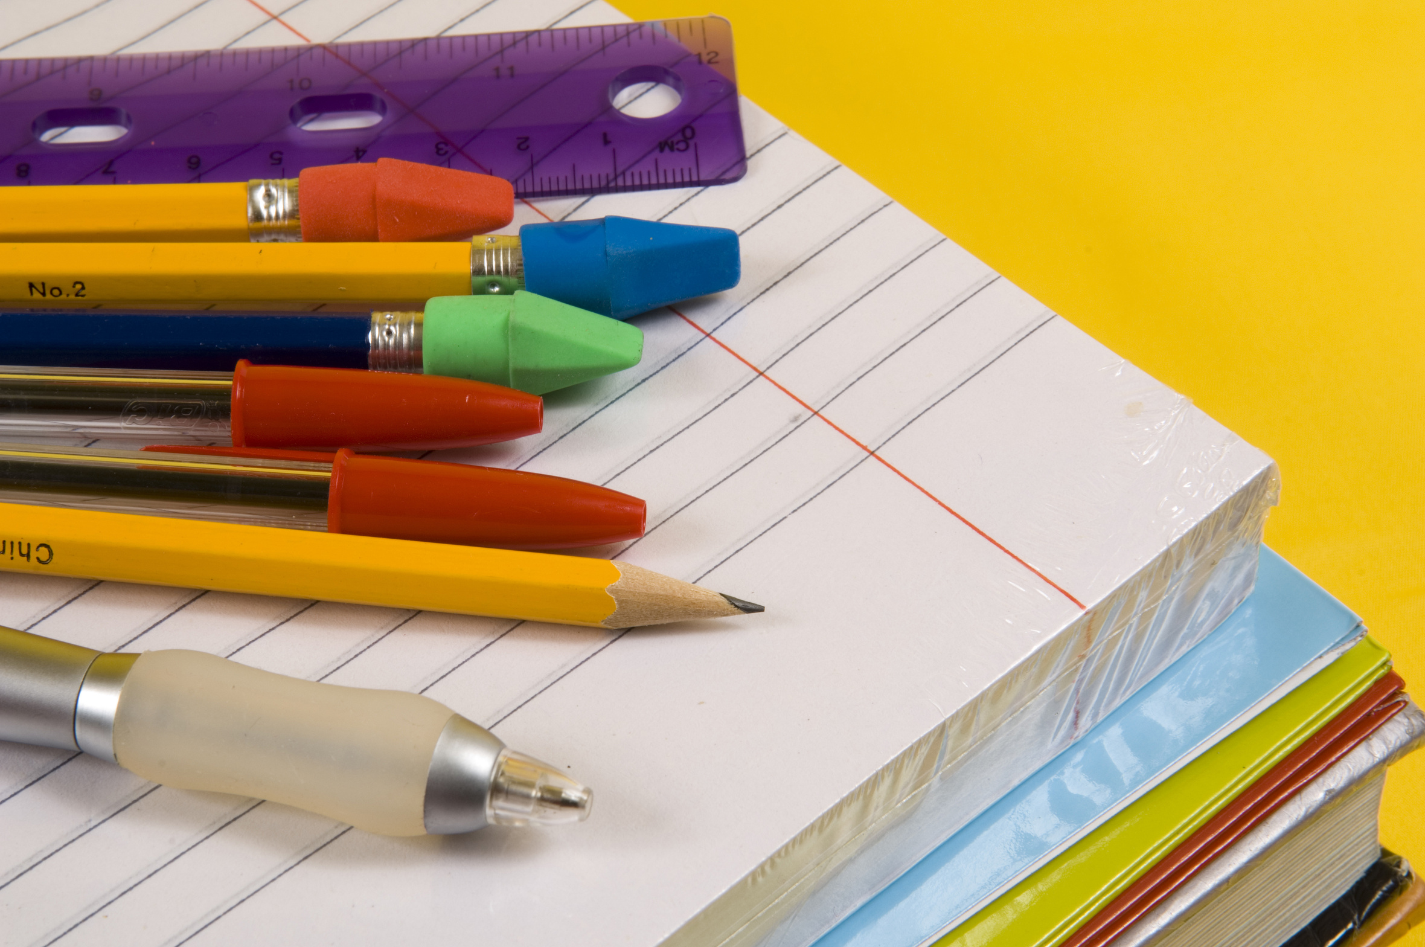
4-Boxes of Markers
4- Index Cards
1-Scissor
1-Ruler
1-Pair of computer headphones

Classroom Use
4-Rolls of Paper Towel (Bounty, etc.)
4-Tissue Boxes
2- Bottles of Hand Sanitizer
2-Container of Clorox Wipes
1-Box of Gallon size Ziplock bags

SEPARATE MATERIALS FOR ART CLASS: Sketch book of unlined blank paper or folder with unlined blank paper Pencils, pens, erasers, scissors, glue stick, tape, ruler, pencil sharpener Color pencil set, Crayons, Markers

☺ Thank You ☺


2024-2025 Lista de Útiles Para el 6th Grado
Mr. Scauzillo and Ms. Minaya

8- Cuaderno Mármol Negro Blanco
4- Paquete de papel suelto
1 Paquete papel en BLANCO de computadora
2 Paquetes papel de graphica
6- Folder plasticos
1- Planeador (2024-2025)
8- Cajas de Lápices # 2 PLUMAS
4-paquetes de POST-IT (libretitas de nota con pegamento)
1 Paquete Marcadores de subrallar
1- Paquete papel de construcción
1- Paquete Marcadores de pizarra- Dry Erase Marker (thick)
6- Glue Sticks (Pega)
1- Bolsa de guardar los útiles
1- Sacapuntas -Personal con tapa
2- Cajas de crayones
1- Caja de marcadores
4- Paquetes de Tarjetas fichas
1- Tijera
1-Regla
1-Par de audífonos de computadora

Para la Clase
4-Rollo de toallas de papel (Bounty)
4- Paquetes de caja de papel
2-Sanitizer/desinfectado
2-Toallitas Clorox Limpiador
1-Caja de Ziplock fundas- Gallon

SEPARATE MATERIALS FOR ART CLASS: Sketch book of unlined blank paper or folder with unlined blank paper Pencils, pens, erasers, scissors, glue stick, tape, ruler, pencil sharpener Color pencil set, Crayons, Markers

** Asegúrese de escribir su nombre en todos los útiles **
GRACIAS

